**Point of Sales System**

1. **Definition**

In modern retail and hospitality businesses, efficient and accurate sales processing is critical to success. The current sales management process in our organization relies on outdated methods that result in inefficiencies, errors, and delayed reporting. A Point of Sale (POS) system is required to streamline operations, enhance customer experience, and improve decision-making with real-time data.

1. **Objective**

* Develop a POS system to facilitate seamless transaction processing.
* Provide real-time sales tracking and reporting capabilities.
* Integrate inventory management to automate stock tracking.
* Ensure compatibility with various payment methods (cash, credit/debit cards, mobile payments).
* Improve user experience for both staff and customers.
* Enhance data security and compliance with industry standards.
* Integrating the sales promotion services for local vendors and business.

1. **Scope**

* Design and development of a POS software system.
* Integration with inventory and accounting systems.
* Multi-user access with role-based permissions.
* Deployment on hardware (cash registers, barcode scanners, receipt printers).

1. **Modules**
   1. **Sales Management**

The system will handle all sales-related activities from item scanning to payment processing and receipt generation.

* + 1. **Item Scanning**

Scanning the items using a barcode scanner to add them to the sales list is done here by the cashier.

* + 1. **Price Calculation**

Automatic price calculator calculates the total price including taxes and discounts is done here and at time of payment to cashier window.

* + 1. **Payment Processing**

It processes payments via cash, credit/debit cards, or digital wallets in cashier window.

* + 1. **Receipt Generation**

It generates and print receipts for customers.

* 1. **Inventory Management**

The system will manage the stock levels, updates inventory after each sale, and alerts for

low stock items.

* + 1. **Stock Entry**

It inputs new stock into the system.

* + 1. **Stock Adjustment**

It updates stock levels after sales or returns.

* + 1. **Inventory Tracking**

It tracks inventory levels in real-time.

* + 1. **Low Stock Alerts**

System will generate alerts when stock levels fall below the reorder threshold.

* 1. **Customer Management**
     1. **Customer Data Entry**

Customer will register themselves through the bar code provided and can shop and scan without the help of the cashier or user themselves.

* + 1. **Purchase History Tracking**

They can track and analyze customer purchase history and can learn on the purchasing patterns of the customer.

* 1. **Automated Sales Promotion**

Automated message alerts on offers and discounts on special events like birth-weeks, festivals etc., prior to one-two weeks of the event.

1. **Hardware and Software Requirements**
   1. **Hardware**
      1. Any devices which can support any browser, with an internet connection.
      2. (Can be Optional, depending upon the medium which the client chooses) Barcode scanner and receipt printer
   2. **Software**
      1. **Backend**

* Node.js
* Express.js
  + 1. **Frontend**
* React.js, UI extensions
  + 1. **Database**
* MongoDB
  + 1. **Other tools used in development**
* Git for version control
* VS Code for development

1. **Literature review**
   1. **Zakya**
      1. **Link:** https://www.zakya.com/en-in/
      2. **Inferred findings**

Zakya is a point-of-sale (POS) solution with features focused on inventory management and real-time analytics. However, it lacks advanced payment processing and customer loyalty programs. The system is cloud-based, supports multi-store functionality, and integrates with hardware like barcode scanners. While it provides essential tools for managing sales and inventory, it misses opportunities in enhancing customer engagement through loyalty initiatives or mobile payment options.

* 1. **Odoo**
     1. **Link:** https://www.odoo.com/app/point-of-sale-shop
     2. **Inferred findings**

Odoo is a comprehensive POS system offering real-time inventory management, cloud support, and multi-store functionality. It also includes payment processing, customer loyalty programs, and hardware integration, making it a versatile solution. Odoo stands out for its ease of use and detailed analytics, which allow businesses to make informed decisions. However, its moderate usability suggests a steeper learning curve for new users compared to competitors like Square.

* 1. **Square**
     1. **Link:** https://squareup.com/us/en/point-of-sale/retail
     2. **Inferred findings**

Square offers an intuitive and highly usable POS system with robust payment processing, real-time analytics, and hardware integration. It supports multi-store operations and customer loyalty programs, making it ideal for businesses focused on customer engagement. While Square excels in user experience and digital payment options, its inventory management features are not as comprehensive as those offered by Odoo, potentially limiting its application for inventory-heavy businesses.

1. **Project feasibility study**
   1. **Technological feasibility**

* The required technologies are modern, well-documented, and widely used, ensuring availability of support and resources.
* Team familiarity with these tools and frameworks makes implementation feasible.
  1. **Operational feasibility**

A business needs streamlined transaction processing, real-time inventory tracking and enhanced customer experience.

* + The POS system aligns with the organization's goal of improving efficiency and customer satisfaction.
  + Easy-to-use interfaces and automated workflows minimize training needs.
  1. **Financial feasibility**
     1. **Initial cost**
* Software development tools and licensing (Node.js, MongoDB, etc.) are open-source, reducing costs.
* Hardware costs are moderate, with barcode scanners and receipt printers as optional expenses.
  + 1. **Potential savings**
* Reduced labor costs due to automation.
* Minimized errors in transaction processing and inventory management.
  + 1. **Return on Investment**
* Improved customer experience and operational efficiency will likely increase sales and profitability.
* Quick adoption and scalability ensure long-term financial benefits.
  1. **Legal and Compliance Authority**
* Compliance with data protection laws (e.g., GDPR) ensures secure handling of customer and transaction data.
* Adherence to industry standards for digital payments enhances trust and reliability.
* Legal and compliance risks are minimal with proper measures.
  1. **Scheduling Feasibility**
* The project can be completed in 3–4 months, including development, testing, and deployment phases.
* A detailed timeline with clearly defined milestones ensures smooth project execution.

1. **Project Requirement Gathering**
   1. **Requirement Gathering Techniques**
      1. **Stakeholder Interviews**

* Conducted one-on-one and group interviews with store managers, cashiers and owners to identify pain points, desired features, and operational needs.
  + 1. **Surveys and Questionnaires**
* Design a simple survey for store employees or customers with multiple-choice or yes/no questions.
  + 1. **Observation**
* Observed the current sales and inventory processes in real-time to identify inefficiencies and areas for improvement.
  + 1. **Document Analysis**
* Reviewed existing sales logs, inventory management records, and transaction reports to understand the limitations of the current system.
  + 1. **Workshops and Brainstorming Sessions**
* Organized collaborative sessions with stakeholders to prioritize features and develop a shared understanding of project goals.
  + 1. **Prototyping**
* Developed low-fidelity prototypes or wireframes to validate requirements and gather feedback early in the design phase.
  1. **Comparison with Existing Application**
* A detailed comparison was made between the proposed POS system and three popular POS applications—Odoo, Zakya, and Square. This comparison highlights the features offered by each system and identifies opportunities for your system to improve on them.

|  |  |  |  |  |
| --- | --- | --- | --- | --- |
| Feature | Our POS System | Odoo | Zakya | Square |
| Inventory Management | Yes (Real-time tracking and alerts) | Yes | Yes | Yes |
| Cloud-Based System | Maybe | Yes | Yes | Yes |
| Multi-Store Support | Yes | Yes | Yes | Yes |
| Payment Processing | Yes (Supports digital/mobile payments) | Yes | No | Yes |
| Customer Loyalty Programs | Yes (Automated promotions added) | Yes | No | Yes |
| Hardware Integration | Yes (Barcode scanners, receipt printers) | Yes | No | Yes |
| Real-Time Analytics | Yes (Comprehensive dashboards) | Yes | Yes | Yes |
| Ease of Use | Yes (High usability, intuitive UI) | Moderate | High | High |

**Table 1. Comparison between various existing POS system with our project.**

1. **Timeline Chart**

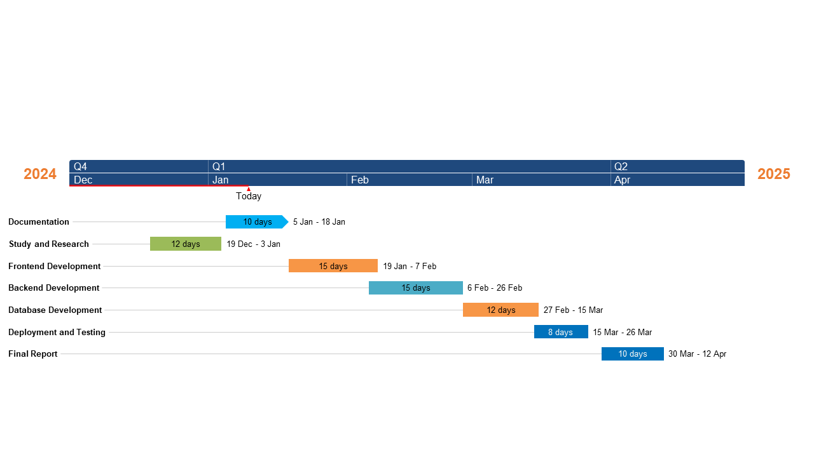

**Figure 1. Time-line chart for project development**

1. **Project Work Distribution**
   1. **For 22IT458**
   2. **For 22IT460**